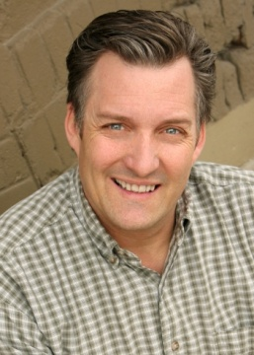

**Dane Allred**

**Height: 5’9” McCarty Talent Agency**

**Weight:175 1380 South Foothill Blvd.**

**Eyes: Hazel Salt Lake City, Utah 84108**

**Hair: Brown cell (801) 636-0725 (801) 581-9292**

**IMDB Films**

**2012 Darkness Bill Lake Productions**

**2012 Thieves Homeless Man Jeremy Productions**

**2011 Must Come Down Mean Interviewer Duane Anderson**

**2010 Treasure in Heaven Martin Harris T.C. Christensen**

**2009 The Alice Winter Dad An Dinh Productions**

**2009 White on Rice Policeman David Boyle Brainwave**

**2006 Big Dreams Little Tokyo Boyd's Dad David Boyle Brainwave**

**2005 Mr. Dungbeetle Upset Women's Husband Reel Focus**

**2004 Terminal The Mark Joseph Sasich Co.**

**2001 Shooting People Harpo Duane Anderson Co.**

**1999 The Old Woman Det. Lowenstein Chapter 11 Productions**

**Other Film**

**Legally Blonde 2/ Congressman/ Reese Prod. Dedicated Service/ Father/ Independent**

**Soldier/ Divided by Hate/Skeerit Inner Voice/ Crazy Man/ BYU Film**

**Osso Bucco Man/ Sundance Film Workshop Jogger/ Alex’ brother**

**Stanley/ ESL Video/ Motion Picture Studio Bar patron/ No Laughing Matter/ Somers**

**Vice-Principal/Hostage High/ Winkler Ward Council/ SS President/ LDS AV**

**Regional and National Commercials**

**Quetenza Industrial Film/ Patient/ Old Crow ITT Tech/ Network Evaluation**

**Cyprus Credit Union/ Business Advisor/ Regional MCI/ Telegraph pole man**

**Utah Credit Union/ Need a Sign/ Christensen O.C. Tanner/ Cheese Head Boss**

**RC Willey/ Stadium Man Nature’s Sunshine/ Jerry Springer**

**Kevin Eubank/ Coat Salesman Novell/ Zinc Oxide Man**

**Theatre**

**Mortimer/ Arsenic/ Little Brown Man In Chair/ Drowsy Chaperone/ Playhouse Butler/ Joseph/ Villa Theatre**

**King/ Big River/ Sundance Outdoor Theatre Charlie/ The Foreigner/ Springville Playhouse Bellamy/ Fantasticks/ PTC**

**Pap/ Big River /Provo Theatre Company Felix/ The Odd Couple/ Little Brown Theatre Baker and Butler/ Scera/ Joseph**

**Charlie/ On Golden Pond/ Little Brown Chuck/ Man Who Came to Dinner/ UVU Publius/ Julius Caesar/ BYU**

**Balthazar/ R&J/ Pioneer Theatre Company Guiseppe/ Man of Destiny/ USU Little Theatre Time/ A Winter’s Tale/ BYU**

**Jury member/ Daniel Webster/ Lyric Theatre Stalker/ Star-Struck/ Provo Theatre Company Henry/ Fantasticks/ PCT**

**Priest/ Much Ado About Nothing/ BYU Doc/ West Side Story/ Scera Priest/ Copelia/ Academy of Ballet**

**Sowerberry/ Oliver! /Hale Center Theatre Officer O’Hara/ Arsenic/ Springville Slim/ Oklahoma! /USU Theatre**

**Clarence/ Wonderful Life/ Art City Theatre Egeus/ Midsummer’s Night/ USU Theatre King/ Big River/ Scera**

**Constable/ Fiddler/ Scera Fender/ Bespoke Overcoat/ USU Theatre Dr. Bradman/ Blithe Spirit/ BYU**

**Buffalo Bill/ Annie Get Your Gun/ PCT Bill/ Take Number/ Springville Playhouse Fagin/ Oliver!/ ACCT**

**Teddy/ Arsenic and Old Lace/ Villa Theatre Arles/Stanley/etc./ Greater Tuna/ Little Brown Froggy/ Foreigner/ Villa Theatre**

**Mr. Bennett/ Pride and Prejudice/ Scera Marcus Lycus/ Forum/ Springville Playhouse Taylor/ 1776/ Scera**

**Special skills and accents**

**Snow-skiing, water-skiing, windsurfing, running, juggling, singing, trombone, accordion**

**Speak German, French, and Russian – accents include these and many others**

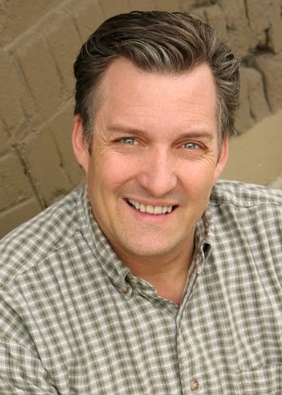

**Dane Allred**